Contents
- Chapter 1: Set Up and BIOS Process 2
  - Goals 3
    - VM Setup and Hardware Understanding 3
    - BIOS/UEFI & Boot Process 3
  - VM Setup and Hardware Understanding 4
    - Purpose 4
    - Setup 5
    - Hardware Component Roles 5
    - Note 5
    - Future Improvements 7
  - BIOS/UEFI and Boot Process Documentation 8
    - Purpose 8
    - Accessing BIOS/UEFI Settings 9
    - Modifying Boot Order and Comparing Legacy vs. UEFI . 9
    - Boot Sequence 10
    - Safe Mode and Recovery Boot Options 11
    - Note 11
    - Future Improvements 12
- Chapter 2: Operating System Deep Dive 13
  - OS Architecture Exploration 14
    - Compare GUI vs CLI Interfaces 14
    - Kernel vs User Space 15
    - 32-bit vs 64-bit 16
  - Process and Service Management 17
    - Systemctl: Using Systemctl for Creation, Removing Ser- vices, Creating Custom Service 17
    - Process vs Thread 19
- Chapter 3: Network Configuration 20
  - Configure Different Network Mode 20
  - Set up Communication between VMs 21
    - Practical Images 21
  - Few Network Troubleshoot like ping, traceroute (tracert), netstat
(ss) 22
    - Practical Images 22
  - License 22

CHAPTER 1: SET UP AND BIOS PROCESS
GOALS:
  - VM Setup and Hardware Understanding
1.2 BIOS/UEFI & Boot Process

  - VM SETUP AND HARDWARE UNDERSTANDING

- Purpose
This self-paced project focuses on setting up virtual machines using VirtualBox or VMware,
installing Windows 10/11, and understanding the roles of hardware components in vir-
tualization. The goal is to practice creating and managing VMs for learning and experi-
mentation

- Setup
2.1 Requirements
• Software:
– VirtualBox (version 7.0 or later) or VMware Workstation Player (version 17 or
later).
– ISO file for Windows 10/11 (e.g., Win11_24H2_English_x64.iso).
• System Requirements:
– Host OS: Windows 10/11, macOS, or Linux.
– Minimum 8GB RAM, 4-core CPU, 100GB free storage (SSD recommended).
• Dependencies:
– Virtualization enabled in BIOS (VT-x/AMD-V)

2.2 Installation Steps
1. Install Virtualization Software:
• Download VirtualBox from https://www.virtualbox.org
• Follow installer prompts to complete setup.
2. Create Virtual Machine:
• Open VirtualBox and select “New VM.”
• Configure VM specs:
– Windows 10/11 VM: 2GB RAM, 2 CPU cores, 50GB storage (dynamic allocation).
• Assign Windows ISO file.
- Kali Linux VM: 2GB RAM, 2 CPU cores, 25GB storage (dynamic allocation).
• Assign Kali-linux-2025.2 ISO file.
3. Install Windows 10/11:
• Boot VM, enter product key (or skip for trial), select “Custom Install.”
• Follow prompts to partition disk and complete setup.
4. Verify Setup:
• Ensure the VM boots correctly and network is configured (e.g., NAT for internet
access)

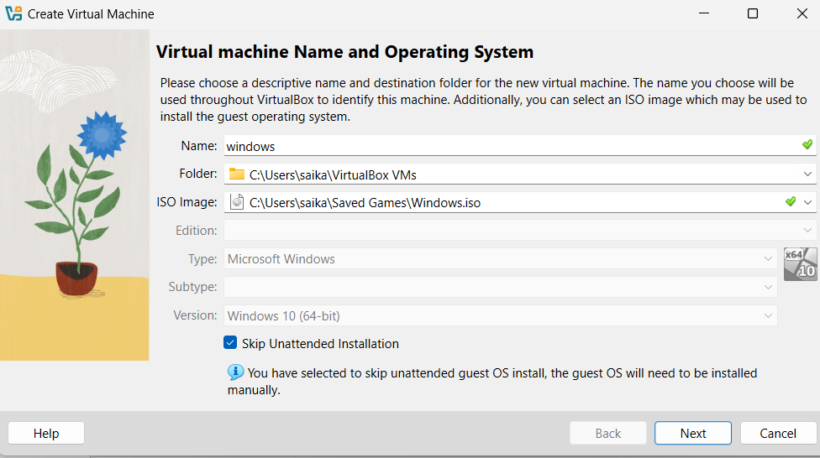

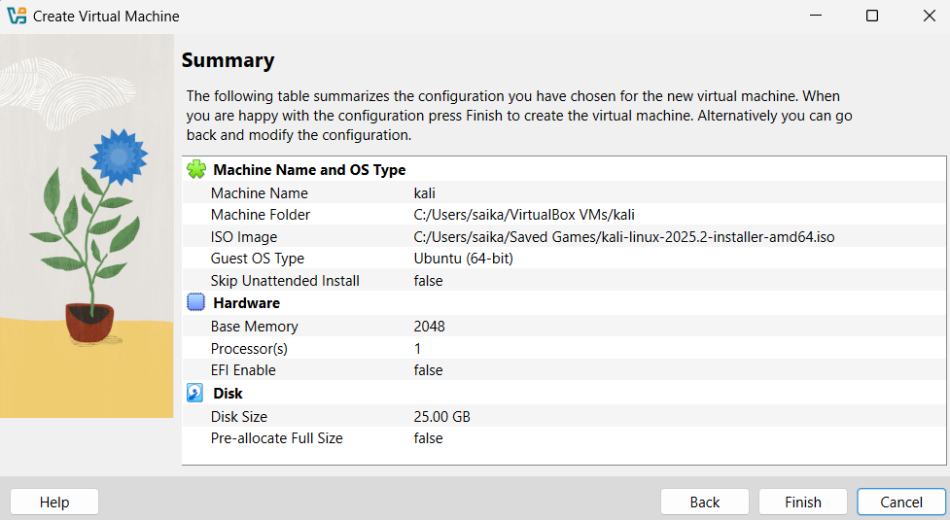

3.Hardware Component Roles
• CPU:
– Powers VM processing, such as running the OS and applications.
– More cores allow smoother performance, especially with multiple VMs.
• RAM:
– Provides memory for the VM; 2GB minimum ensures Windows runs efficiently.
– Insufficient RAM may cause lag or crashes.
• GPU:
– Handles graphical rendering for Windows desktop and applications.
– Enable 3D acceleration in VM settings for improved visuals.
• SSD/HDD:
– Stores VM disk images and OS files.
– SSDs offer faster boot times and responsiveness compared to HDDs.

Note:
• Challenges:
-VirtualBox was pretty new and made few mistakes while configuring my VM
-Wrong configuration lead to os crash
•lessons:
-I was able to learn configuration within the VM box to particular os

Future Improvements
• Create additional VMs with different OS versions (e.g., Windows Server).
• Experiment with bridged networking for VM-to-host communication.
• Test resource-intensive applications to study hardware limits.
• Hoping this Cyber lab Environment

  - BIOS/UEFI and Boot Process Documentation
1 Purpose
This self-paced project explores BIOS/UEFI settings and the boot process in virtual ma-
chines using VirtualBox or VMware. The objectives are to access and modify BIOS/UEFI
settings, compare Legacy and UEFI boot modes, document the complete boot sequence
from power-on to desktop, and practice Safe Mode and recovery boot options for learn-
ing purposes.

2 Accessing BIOS/UEFI Settings
1. VirtualBox:
• Select the Windows VM and click “Settings” > “System” > “Motherboard.”
• Enabl e “Enable EFI (special OSes only)” for UEFI mode; disable for Legacy BIOS.
• Start the VM and press F2 repeatedly during boot to enter BIOS/UEFI setup

2.Modifying Boot Order and Comparing Legacy vs. UEFI
• Modifying Boot Order:
– In BIOS/UEFI, navigate to the “Boot” menu.
– Adjust boot priority (e.g., prioritize virtual hard disk over CD/DVD).
– Save changes (usually F10) and reboot to test.
• Legacy vs. UEFI Comparison:
– Legacy BIOS: Uses MBR partitioning, simpler interface, limited to 2TB disks, no
Secure Boot.
– UEFI: Supports GPT partitioning, graphical interface, larger disks, and Secure
Boot for enhanced security.
– Tested both modes in VM settings; UEFI required GPT disk setup during Windows installation.
3 Boot Sequence
The complete boot sequence from power-on to desktop in a Windows 10/11 VM:
1. Power-On: VM initializes virtual hardware (CPU, RAM, etc.).
2. POST (Power-On Self-Test): BIOS/UEFI checks virtual hardware integrity.
3. Bootloader: Loads Windows Boot Manager (UEFI) or NTLDR (Legacy).
4. Kernel Loading: Windows kernel initializes, drivers load.
5. User Interface: Login screen appears, followed by desktop after user authentication.
Observation: UEFI boot is faster due to streamlined firmware; Legacy boot showed slight
delay
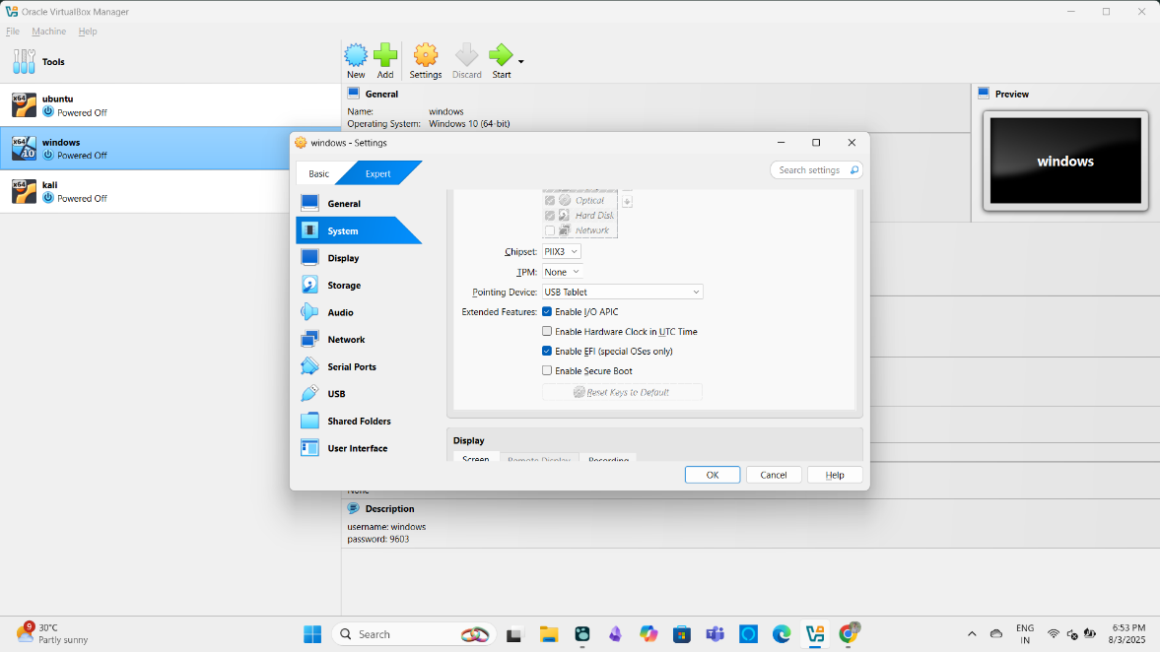

4.Safe Mode and Recovery Boot Options
1. Safe Mode:
• Restart VM, press F8 (or Shift + F8 in UEFI) during boot.
• Select “Safe Mode” from Advanced Boot Options.
• Result: Boots with minimal drivers; used to test system stability.
2. Recovery Options:
• Access via Settings > System > Recovery > “Restart now” under Advanced Startup.
• Alternatively, interrupt boot three times to trigger Automatic Repair.
• Options tested: System Restore, Startup Repair, Command Prompt.
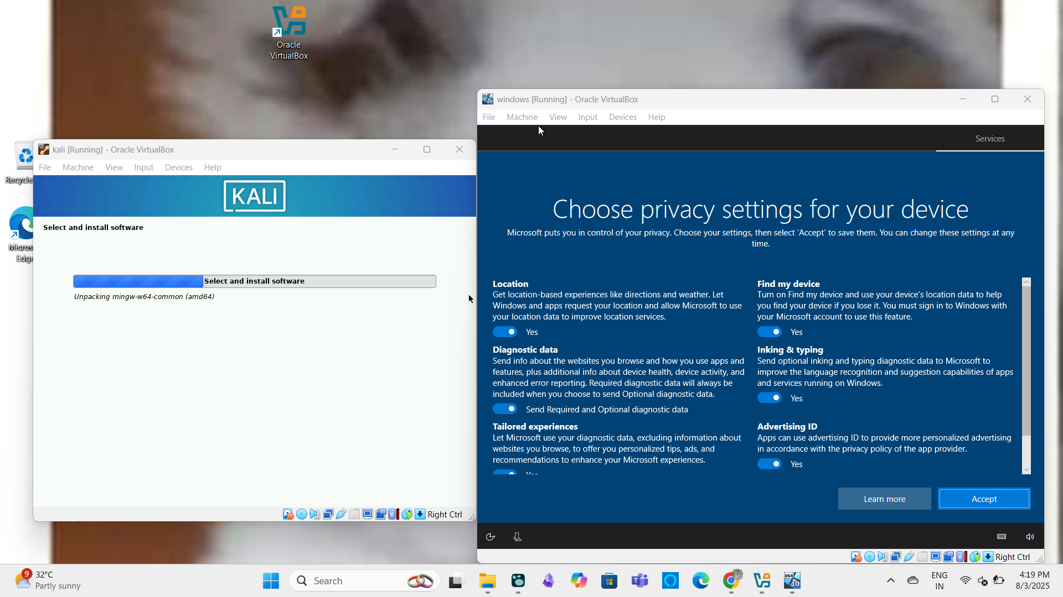
Note:
- Challenges:
- Enabling EFI Without 2nd boot in VM requests for bootable OSI image even able proper boot
- Using precise timing with f2 for boot is kind of tricky
- Lessons Learned: UEFI’s Secure Boot enhances security but requires compatible OS configuration

Future Improvements
• Test boot process with other OSes (e.g., Linux distributions).
• Explore Secure Boot configuration in UEFI.
• Simulate hardware failures to study recovery options in depth

CHAPTER 2: OPERATING SYSTEM DEEP DRIVE

2.1 OS Architecture Exploration
2.11 Compare GUI vs CLI interfaces

Feature | GUI | CLI
Ease of Use | Beginner-friendly and intuitive | Requires memorization and practice
Speed (Execution) | Slower for advanced tasks (requires clicks) | Faster for experienced users (one-liners)
Resources Used | High (needs CPU, RAM, GPU for graphics) | Low (minimal system resource usage)
Automation | Difficult (limited scripting support) | Excellent (supports scripting & automation)
Flexibility | Limited to what's shown in menus | Very flexible, can combine commands (piping, redirection)
Learning Curve | Shallow (easy for new users) | Steep (hard at first, powerful once learned)
Remote Access | Needs remote desktop tools | Easily accessible via SSH
Error Feedback | Visual indicators (alerts, popups) | Text output or error codes

Practical Part
- File explore in (Windows,Linux) using GUI
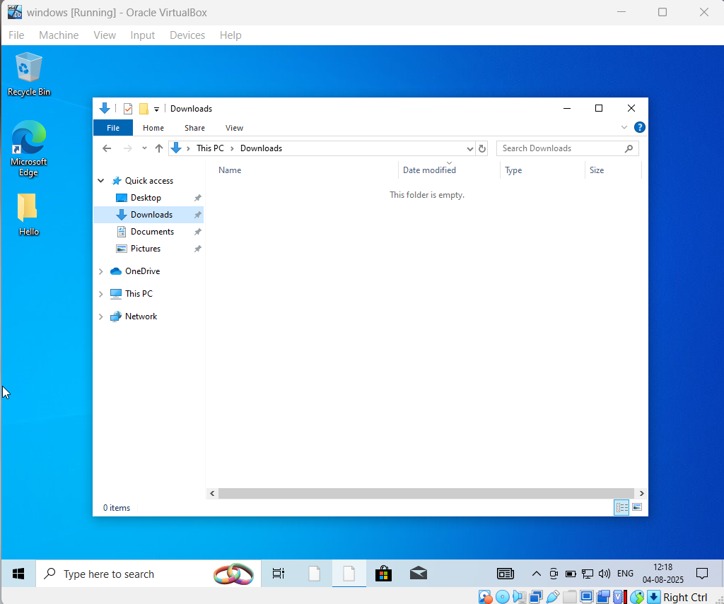
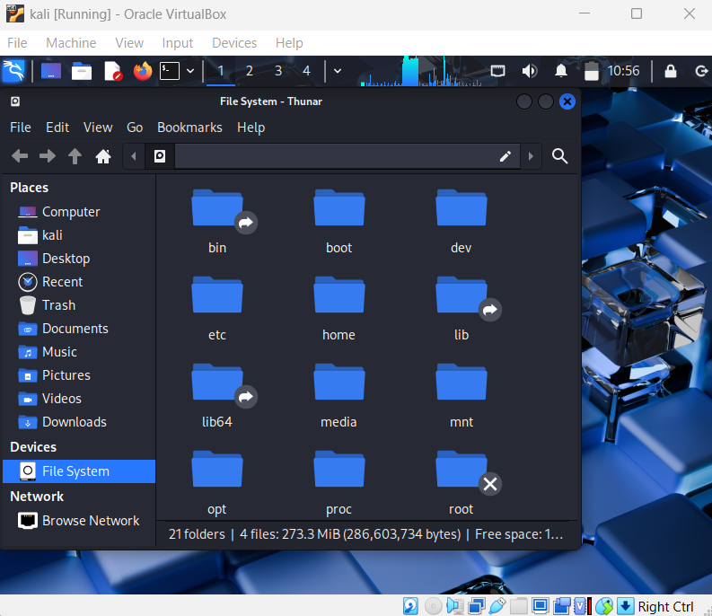

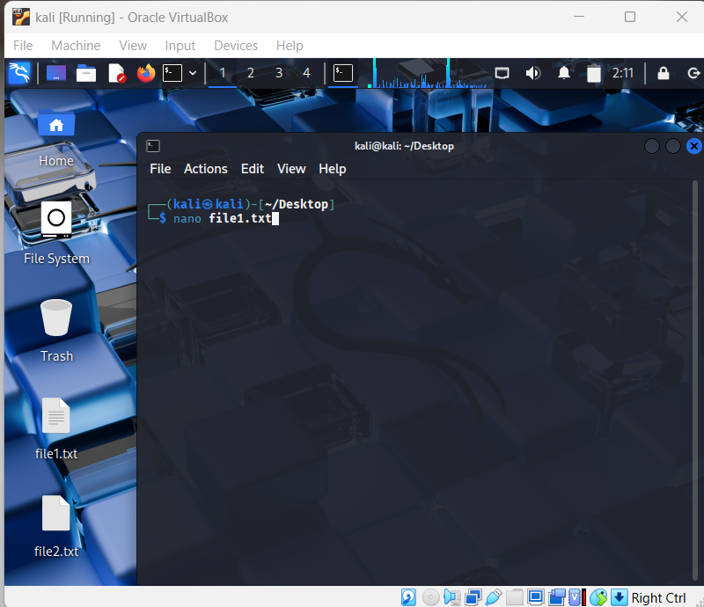
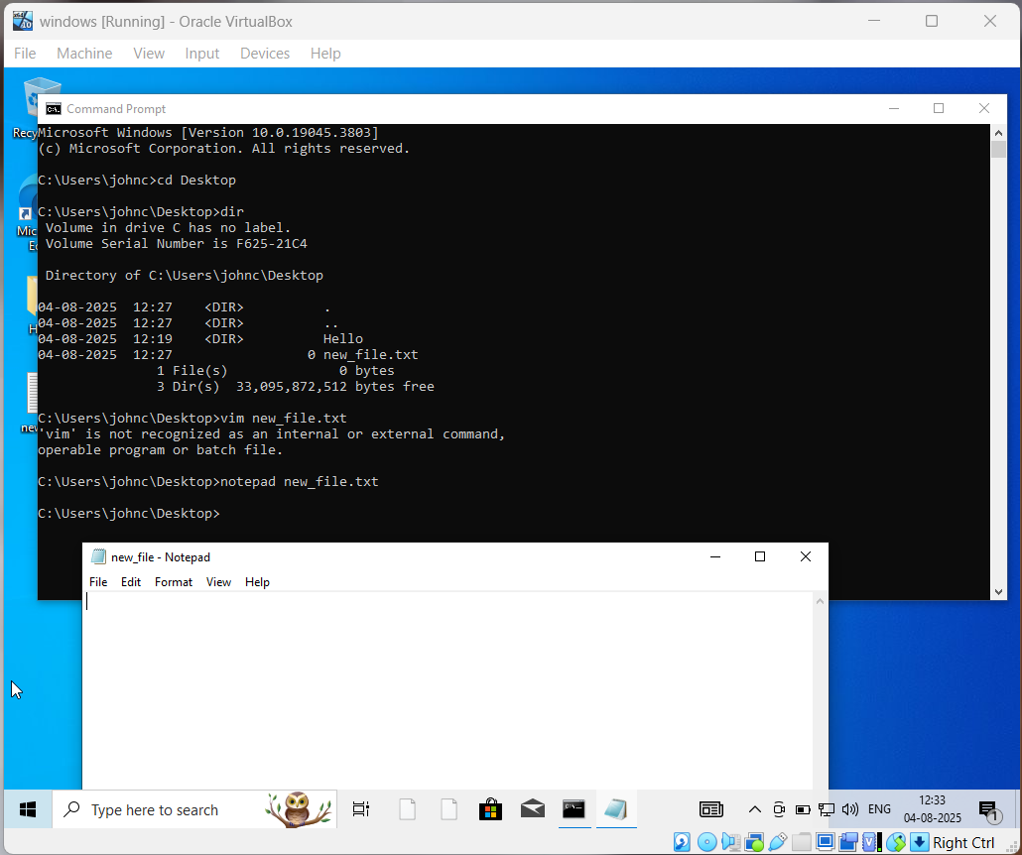
- CLI based file editor

- Similarly all the other practical images are in images/GUIvsCLI/ folder

2 ) Kernal vs user space
Aspect | Kernel Space | User Space
Access Level | Full access to hardware and system resources | Limited access; must use system calls to communicate with kernel
Security | Highly privileged | Less privileged — sandboxed from direct hardware access
Crash Impact | Kernel crash = entire system crash (kernel panic) | User app crash = only that app fails
Examples | Device drivers, process scheduler, memory manager | Web browser, text editor, terminal
Code Execution | Runs in Ring 0 (privileged mode) | Runs in Ring 3 (non-privileged mode)
Memory Protection | Kernel protects itself from user space | User space is isolated from the kernel
Performance | Handles critical tasks quickly | May be slower due to context-switching when calling kernel services

- Practical on Kernel and User space

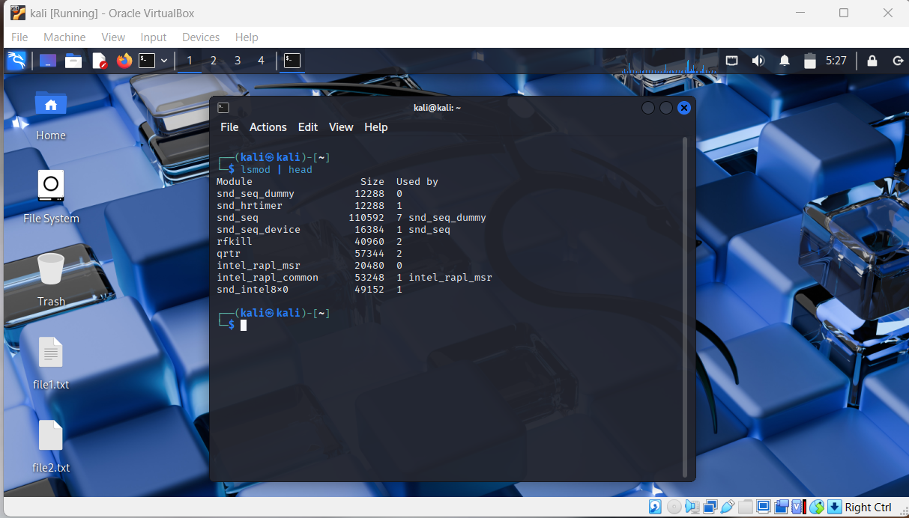
- List of kernel modules and description of each modules
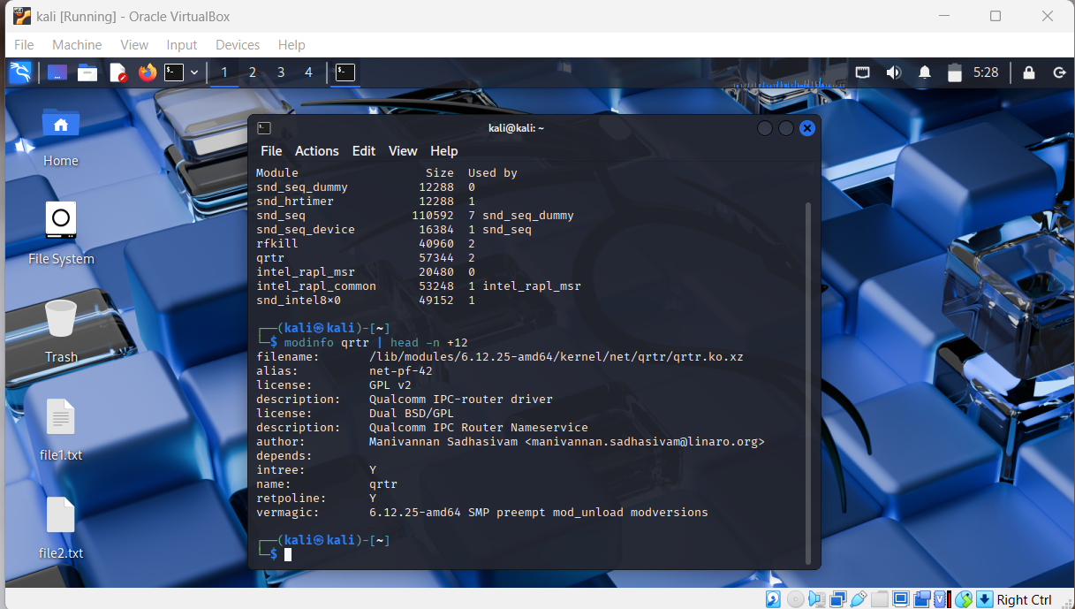
- tracing user space process converting into kernel module using `strace <process/command> `
ex: strace ls
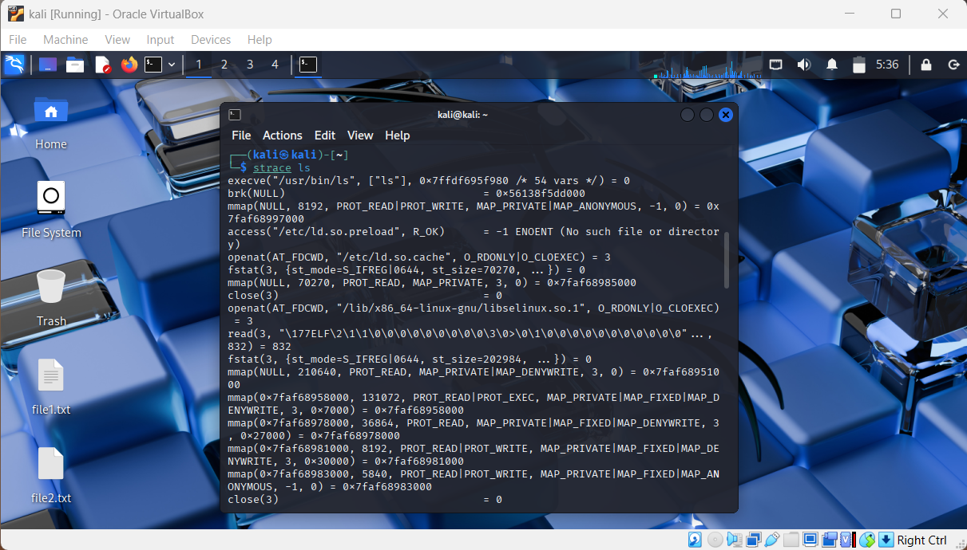
- Similarly also performed list of user space using “ps -aux” , getting logs of kernel buffer using “dmesg”
- Also performed in windows rest of images are in /images/KernelVsUser/ folder

3) 32-bit vs 64 bits
Criteria | 32-bit | 64-bit
Max RAM | ~4 GB | 128 GB+
Software Support | Only 32-bit | 32-bit & 64-bit
OS Compatibility | 32-bit only | Both
Performance | Limited | Better, scalable
Security | Basic | Advanced (more secure)

- Practical Part
- uname -m
i686, i386 → 32-bit
x86_64 → 64-bit in Linux
- systeminfo | findstr /C:“System Type” in windows

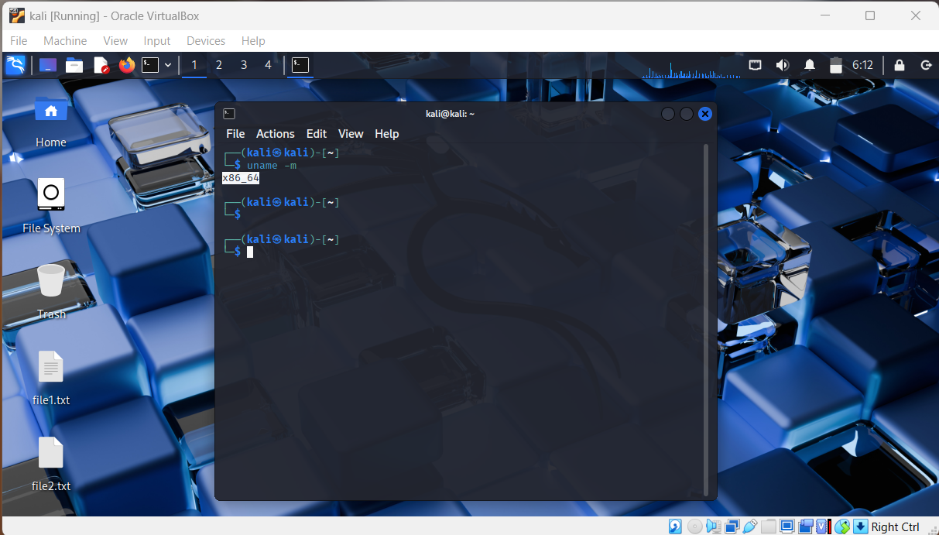
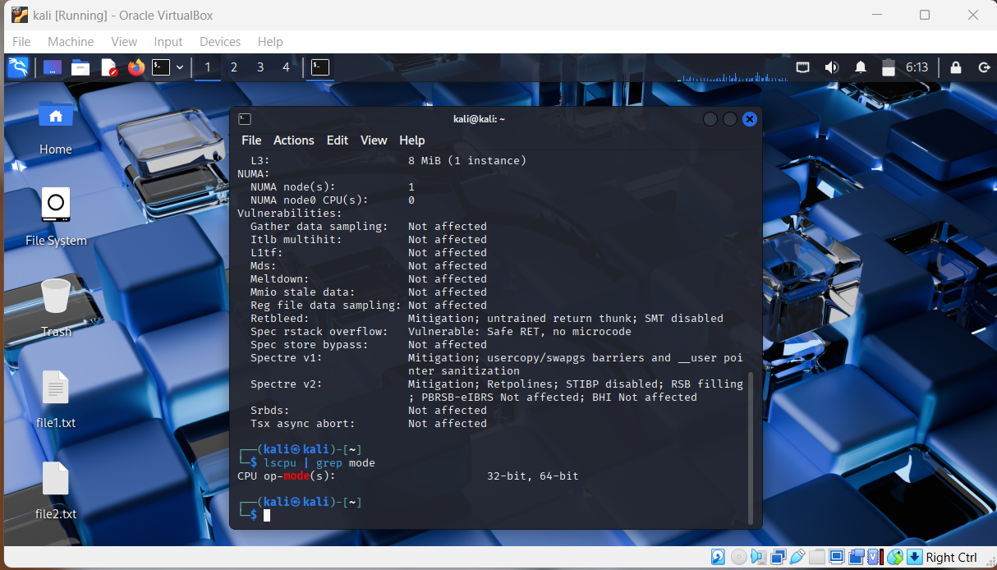

Note: All these images are also mentioned in Images/32vs64 bits/

2.2 Process and Service Management
=> Using Systemctl for creation , removing services, creating custom service

- Systemctl : Using Systemctl for creation , removing services, creating custom service

Creating & Deleting a Custom systemd Service on Linux

Part 1: Create a Custom Service
Step 1: Create the Script
Create the executable script that will run when the service starts.
sudo nano /usr/local/bin/custom_script.sh
Paste this content:
#!/bin/bash
echo "✅ Custom service ran on boot!" >> /var/log/custom_log.log
Make it executable:
sudo chmod +x /usr/local/bin/custom_script.sh

Step 2: Create the Service File
Create a new service file in /etc/systemd/system/:
sudo nano /etc/systemd/system/custom-boot.service
Paste this configuration:
[Unit]
Description=✅ My Custom Boot Service
After=network.target

[Service]
ExecStart=/usr/local/bin/custom_script.sh
Type=oneshot

[Install]
WantedBy=multi-user.target

Step 3: Reload systemd and Enable the Service
sudo systemctl daemon-reload
sudo systemctl enable custom-boot.service
sudo systemctl start custom-boot.service
✅ Verify log:
cat /var/log/custom_log.log

Part 2: Delete the Custom Service
🔻 Step 1: Stop & Disable
sudo systemctl stop custom-boot.service
sudo systemctl disable custom-boot.service

Step 2: Remove Files
sudo rm /etc/systemd/system/custom-boot.service
sudo rm /usr/local/bin/custom_script.sh
sudo rm /var/log/custom_log.log # Optional

Step 3: Reload systemd
sudo systemctl daemon-reload
Confirm removal:
systemctl status custom-boot.service
Expected:
Unit custom-boot.service could not be found.

Process vs Thread:

Process
- An independent unit of execution with its own memory and resources.
- Heavyweight – creating and managing processes is resource-intensive.
- Crash in one process doesn't affect others.
- Used for isolated tasks, like running separate programs.

Thread
- A lightweight unit within a process; shares memory/resources with other threads in the same process.
- Faster to create and switch.
- Crash in one thread can affect the whole process.
- Used for parallelism within the same application.

Chapter 3: Network Configuration
3.1 Configure different network mode

1. NAT (Network Address Translation)
Default & safest for internet access
What it does:
- VM shares host's internet using virtual NAT router.
- VM can access the internet.
- Other machines cannot access the VM.
Use Case:
- Safe internet access for updates or downloads.
- Good for penetration testing tools that require outbound connections.
Configure:
- Go to VM Settings → Network → Attached to: NAT
- No extra setup required.

2. Bridged Networking
VM acts like a real device on your LAN
What it does:
- VM connects directly to your physical network (LAN).
- Gets an IP address from your router, just like your host PC.
- Other devices on the same LAN can reach the VM.
Use Case:
- Testing network tools like Wireshark, Nmap, FTP servers.
- Simulate real device behavior.
- Use VM as a server visible to other devices.
Configure:
- Go to VM Settings → Network → Attached to: Bridged Adapter
- Select correct physical network interface (Wi-Fi/Ethernet).
3. Host-Only Adapter
VM talks only with host
What it does:
- VM is isolated from internet & other networks.
- VM can communicate with the host via a virtual adapter.
- IPs are from a private range (e.g., 192.168.56.0/24).
Use Case:
- Lab environments where host needs to send files to VM.
- Secure setups with no internet access.
- Testing or capturing traffic between host and VM.
Configure:
- Go to VM Settings → Network → Attached to: Host-Only Adapter
- Ensure VirtualBox Host-Only Network Adapter is installed.

Practical Images
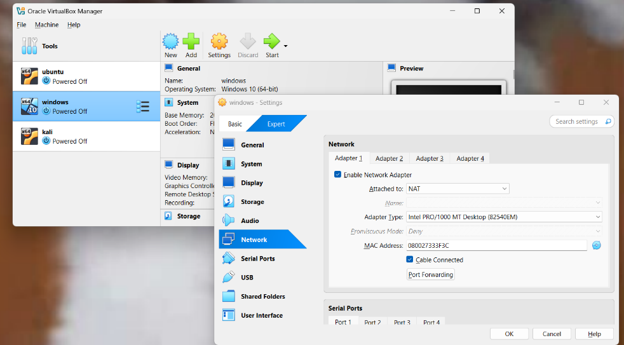

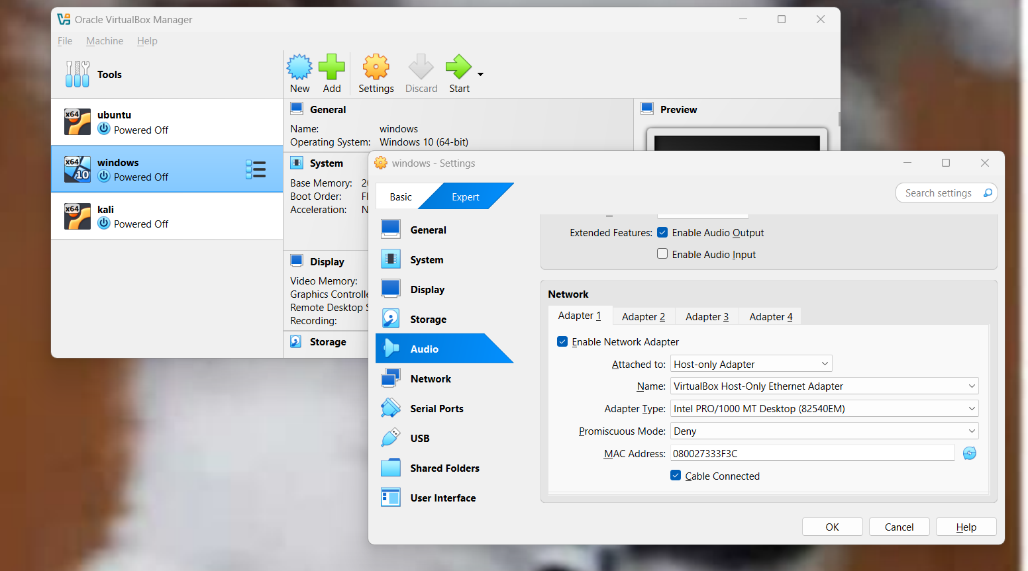

3.2 Set up Communication between VMs

- After configuration of Network mode
  - Use “ ip a” in Linux to know IP address of Linux VM
  - Use “ip a” in Ubuntu to Know IP address of Ubuntu VM
- Use “ping < Ubuntu IP address> through Linux VM
- Use “ping <Linux IP address> through Ubuntu VM
- If successful “n packets transferred, n received, 0% loss, time km/s

Practical Images
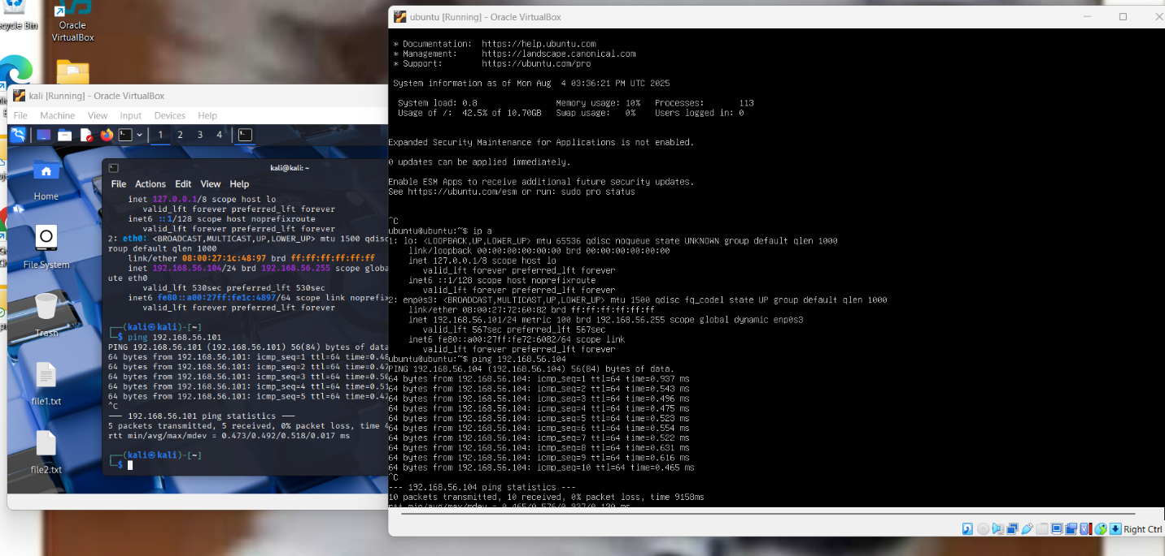

Note: Windows VM doesn’t support HOST-only adapter

3.3 Few network troubleshoot like ping , traceroute ( tracert), netstat ( ss)
=> ping: Tests connectivity between your system and another network host by sending ICMP echo requests.
=> traceroute / tracert: Traces the path packets take to reach a destination by showing each hop along the route.
=> netstat / ss: Displays active network connections, listening ports, and socket statistics on your system.

Practical Images:
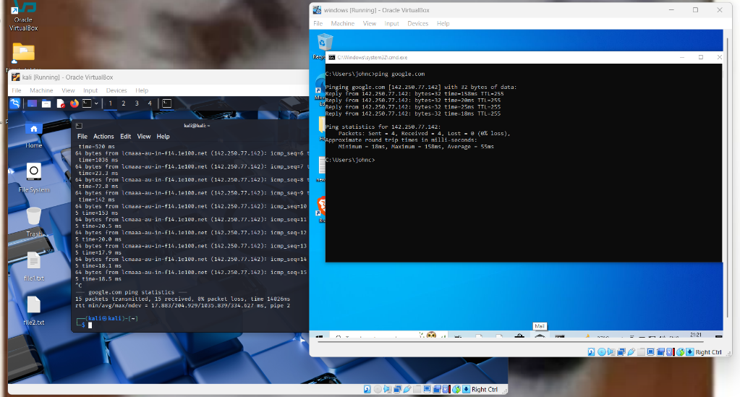
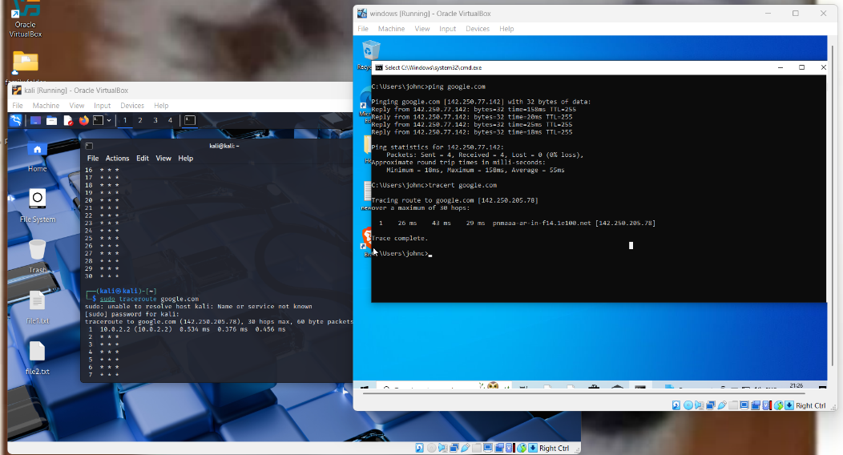
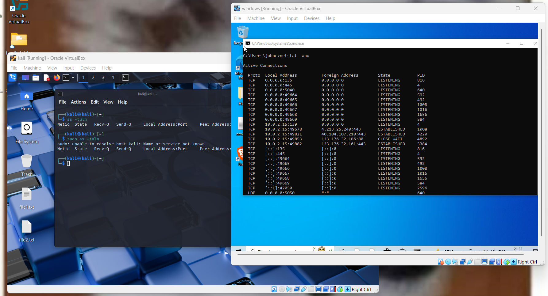

Lincense:
This project is for personal learning and not licensed for distribution

